**Paraphrasing**

Paraphrasing is one way to use a text in your own writing without directly quoting source material. Anytime you are taking information from a source that is not your own, you need to specify where you got that information.

A PARAPHRASE IS...

* Your own interpretation of key information and ideas expressed by someone else.
* One appropriate way (when accompanied by accurate documentation) to borrow from a source.
* A more detailed restatement than a summary, which focuses on a single main idea.

PARAPHRASING IS A VALUABLE SKILL BECAUSE...

* It is better than quoting information from an ordinary passage.
* It helps you control the temptation to quote too much.
* The mental process required for successful paraphrasing helps understand the meaning of the original text

STEPS TO EFFECTIVE PARAPHRASING

1. Reread the original passage until you understand its full meaning.
2. Set the original aside, and write your paraphrase on a note card.
3. Jot down a few words below your paraphrase to remind you later how you envision using this material.
4. Check your version with the original to make sure that it accurately expresses all essential information in a new form.
5. Use quotation marks to identify any unique term or phraseology you have borrowed exactly from the source.
6. Record the source (including the page) on your note card so that you can credit it easily if you decide to incorporate the material into your paper.

In text citation example

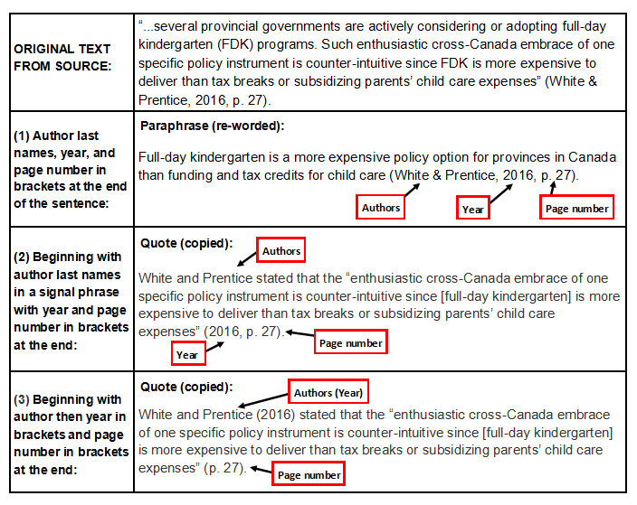

The example uses The APA form of citations

**Practice exercise**

* **Paraphrase the following sentences.**

1. **The student requested that the professor excuses her absence, but the professor refused.**
2. **There will be a music concert next to Vienna coffee shop. Would you like to go?**
3. **International Center is hosting English Conversation classes. They help non-native speakers of English practice their English speaking skills.**
4. **The office of International Students and Scholars at Purdue University is located in Schleman Hall.**
5. **The car that was pulled over by the police officer yesterday just had an accident. That driver was not careful.**

**Rubric**

|  |  |  |  |
| --- | --- | --- | --- |
| **Criterion** | **Exceeds Expectations** | **Meets Expectations** | **Below Expectations** |
| **Points earned** | **3** | **2** | **1** |
| **Main Idea** | **Main idea is clear** | **Main idea is hinted on** | **Main idea is incorrect** |
| **Detail** | **Relevant detail included** | **Some relevant detail missing** | **Too many or no details** |
| **Paraphrase** | **sentence and word order changed** | **Some sentences put into own words** | **Sentence copied from text** |
| **Grammar** | **Sentence structure is varied** | **Sentence structure is simple** | **No change in Sentence structure** |
| **Spelling / punctuation** | **1.5** | **1** | **0.5** |
| **No spelling/ punctuation errors** | **some spelling/ punctuation errors** | **Many spelling/ punctuation errors** |
| **References** | **Accurate use** | **Partly accurate use** | **Incorrect/missing references** |